Jacob and Jack

Finalised proposal of the digital wellbeing app (MindfulTech)

Table of Contents
Introduction To Project 2
Research 3
Technical Specifications 4
Wireframes 5
Feedback Strategy 9
Conclusion 10

Introduction To Project

In modern day, the evolution and progress of technology is evidentially clear and the future growth and investment in this sector is boundless. We are constantly inventing and implementing new technologies to further enhance our living standard and reduce the burdens we carry in our way of life. This means that we are repeatedly automating the daily tasks that we must carry out in our lifestyles. However, has anybody questioned the results of over reliance on technology? Here at MindfulTech we have researched the possible outcomes and the real-life effects that are impacting us in this digital age.

Research

In our research we found that:
- Mental health issues among 16–25-year-olds have become much more prevalent as there has been an over 3 million people increase in 16–25-year-olds reporting long term mental illness.
- Between 2020/21 and 2022/23 mental health referrals in the NHS for young people has increased by over 50%. This has risen from 821,734 to 1,288,653 for individuals aged 10-24
- This has led to 45% of the overall disease burden with suicide the second leading cause of death
- 60% of disability experienced by those aged 15 – 34 is caused by mental illness
- 12% of people aged 16 – 24 have self-harmed at some point.
- Young people often take drugs and alcohol to fit in and try new things however, this leads to a decline in mental health
- They can lead to problems such as addiction, depression and schizophrenia

Citations for research:
Understanding the crisis in young people’s mental health - The Health Foundation
CentreforMentalHealth_MissedOpportunities_16-25years.pdf
How drugs and alcohol can affect your mental health

Technical Specifications

Some Key features in our app will be:
- Screen time tracking
- Displaying personalised wellbeing tips
- Personalised notifications

One Key feature that will make our app stand out will be an option for the user to partake in mind puzzle games to help stimulate their brain in a different direction compared to other apps as well as mind relaxation games to help reduce things like anxiety and stress. Another key feature is a progressive garden they can care for and cultivate. However, to gain items and such for this garden they must earn a type of points in which they can gain from completing their personal goals as well as accumulate these points from being away and offline from their phone
To complete this feature, we will need someone who is efficient in coding games, someone who is proficient in graphics design and someone who can evaluate the accessibility and security of the game.
The tools we would need would be programming languages such as C# and python, Graphics such as photoshop and blender to give more immersion to the experience. And a suitable to device to run and test the app on.

To run the app must:
- Run smoothly (load all pages in under 2 second)
- Be up to security protocols, laws and regulations
- Must be accessible to a wide range of people and be available on multiple different devices e.g. laptop, phone, tablet
- Must keep users anonymous so they feel safe and secure on the app
- Having permission from user to track screen activity and physical activity such as steps

Wireframes

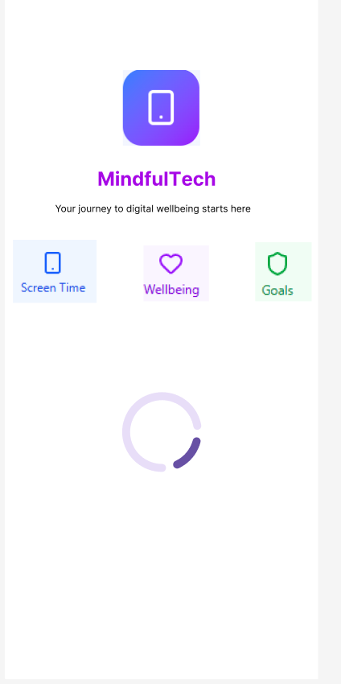
This is the loading screen of our digital wellbeing app. It includes our apps logo and also our apps name. Cool colors like blue, green, and purple have a calming, relaxing, and focus-enhancing effect on the brain and mental health, therefore this has become the image of our logo and also the colour gradient of our app. Blue can slow heart rate, reduce stress, and promote calm. Green is known to stabilize emotions and reduce anxiety, while purple can inspire creativity and spirituality. The loading screen also includes the main ideas and functions of our app. This helps to showcase what is in our app as to not overwhelm a user when the app is opened. A simple loading icon can be shown on the home screen.
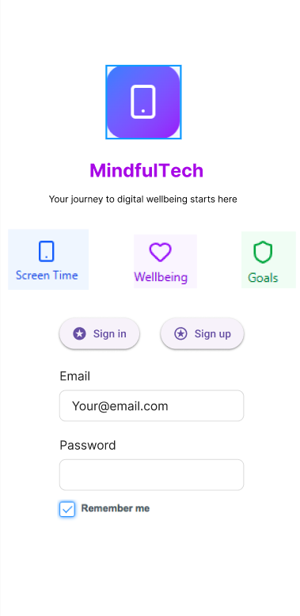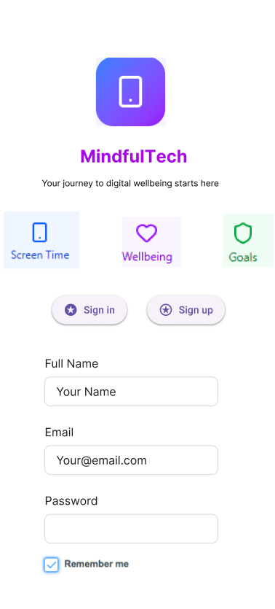
This is our sign in and sign-up page. If it is a first-time user or the user chooses not to remember their login details, then these are the pages they will see. Thes pages contain the same features as the loading screen such as the app logo, icons and colour scheme. Depending on the needs of the user they can easily switch between signing up and logging in through the tough of a button (featured as sign in and sign-up buttons).
The user is then urged to enter their details based on if they need to sign in or sign up. They then must enter the required details, after that they are able to access the app homepage. If the user chooses to tick the ’remember me’ box, then in future logins they will be able to bypass these pages and load straight into the app.
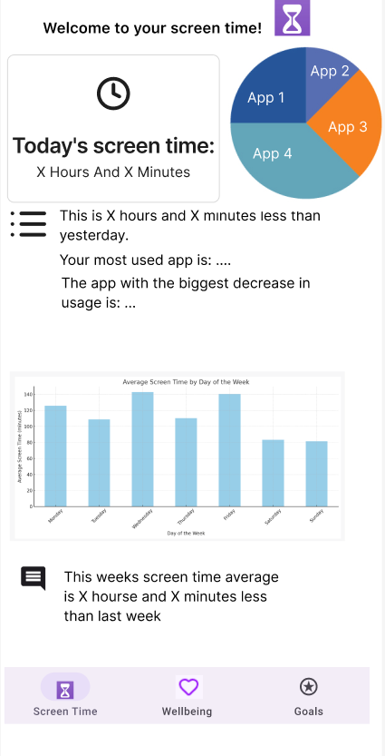
This is the homepage of our wellbeing app. It consists of the same colour scheme as all the other pages of the app for consistent visual effects. It consists of three different pages: ’Screen Time’, ’Wellbeing’ and ’Goals’. These pages consist of the main features of our app, and each page has a different goal for the user's digital wellbeing and mental health.
The first page ’Screen Time’. The Screen time page has a short introduction to the page's contents at the top of the screen as well as the page logo (for visual enhancement purposes). It then has a large display feature of the user's current daily screen time in hours and minutes. This provides a visual for the user of their phone use making it convenient to keep in check. To the right of this display is a pie chart visual. This visual highlights the different apps the user has been on in the day, and it is an excellent way to present the different usage times showing them exactly what apps they need to cut back on. Underneath these informants is a note display section. This section contains written information on different aspects of their phone usage. It contains information based on app performances giving them helpful insights into their phone usage including positive feedback of their screen habits. Underneath the informative notes is a bar chart. This bar chart is an overview of the users daily screen time based on different days of the week. This benefits the user by visualising their screen habits and gives an overview of their latest screen habits over multiple days.
The main goal of visualising the users screen usage is to illustrate their digital habits to them in a simple way. This can benefit them as if they see healthy progress in their phone usage then this can create a snowball effect into wanting to constantly improve.

Feedback Strategy

How will we gather feedback?
We will gather feedback by conducting a wide range of research methods such as Surveys, asking people questions and tracking user activity.
We will use tools such as google forms where users can enter answers based on scores depending on the experience, printed questionnaires where users who may not have access to internet can also give feedback

Who will our audience be?
We will primarily ask users aged 16-25 for their feedback as that is the target audience for our app so we will want their feedback to help us improve. However, we will also ask for various other feedback such as other programmers/developers, elderly people, school age people and working age adults. Getting feedback from other programmers and developers will help us make improvements to our code and efficiency of our code as we will show them our code and ask them how we can improve. Having older people test the app will help us see how they use it and see if it is any different to how younger people use the app. It will also allow us to add and test our accessibility features.

Type of questions we could ask
Open:
- What other features could we add to the app to improve it?
- What did you like about the app?
Closed:
- How easy was it to navigate the app?
- Where our accessibility features useful?
- Would you be likely to use this app?

Conclusion

Why the app is needed
The app is need due to the large increase in mental health issues among young adults aged 16-25 with over 50% increase in mental health issues
Basic requirements
The app should run smoothly, be accessible, have progression features, and have good security features
Why they help
This helps as it makes the app more engaging and attractive for the user
Challenges we faced
We faced many challenges such as accessibility features and much more such as security issues and getting a good design.

